Machine Learning
Development Team Project

Airbnb Business Analysis Using a Data Science Approach
Assignment 1 Project Report - Track 1

Abdulrahman Alhashmi; Jose Torres; Lauretta Oghenevurie; Rebecca Jones; Tasnika Goorhoo

09-08-2025

Table of Contents
Table of Figures……………………………………………………………….......…….….3
- Introduction and Business Question .........................................…………….4
- Rationale and Expected Business Impact .................................................. 4
- Methodology ................................................................................................ 5
3.1 Data Preparation and EDA ......................................................................5
3.2 Regression for Price Prediction ...........................................….………….5
3.3 Clustering for Customer Segmentation ..........................…….…….….….5
- Results ..........................................................................................................6
4.1 Regression Results ................................................................................. 6
4.2 Clustering Results ....................................................................................7
- Discussion .....................................................................................................9
- Conclusion and Recommendations ............................................................. 10
- References ................................................................................................... 11
- Appendices .................................................................................................. 13

Table of Figures

- Figure 1. Elbow Method showing optimal cluster number (k = 3)
- Figure 2. Predicted vs Actual Listing Prices (Random Forest Regression)
- Figure 3. Feature Importance Ranking (Random Forest Regression)
- Figure 4. Clusters of Listings by Price and Minimum Nights
- Figure 5. Clusters of Listings by Price and Number of Reviews

- INTRODUCTION AND BUSINESS QUESTION
The sharing economy has transformed industries such as transport, retail, and accommodation, generating over $335 billion in revenue and projected to grow by 25–30% in the next five years (Chua, Chiu & Bool, 2019). Airbnb is a leading disruptor, challenging hotel models and enabling hosts to earn flexible income while offering travellers affordable, localised experiences (Oskam & Boswijk, 2016).
New York City (NYC) is one of Airbnb’s most competitive markets, with high demand, limited vacancy, and rising land values driving accommodation costs (Li & Xie, 2020). This environment makes it an ideal setting to examine pricing strategies and customer behaviour.
This project addresses two central business questions.
- How accurately can Airbnb listing prices in NYC be predicted based on property characteristics, location, and availability?
- Can Airbnb customers be segmented according to booking patterns and preferences to inform pricing strategies?

- RATIONALE AND EXPECTED BUSINESS IMPACT
This project applies classical machine learning approaches, regression for price prediction and clustering for segmentation. Accurate price prediction is critical for reflecting demand shifts and maintaining competitiveness (Zhang et al., 2017), while segmentation enables Airbnb to identify traveller preferences and tailor strategies (Guttentag et al., 2018). Research shows multi-listing hosts gain efficiency, whereas single-unit hosts provide more personalised stays; both depend on precise pricing and customer insight (Kwok & Xie, 2019).
The expected impact is twofold: optimised pricing to maximise host revenue and sustain Airbnb’s competitive edge, and segmentation insights to personalise experiences. Together, these outcomes strengthen Airbnb’s long-term growth and leadership in the sharing economy.

- METHODOLOGY
3.1. Data Preparation and EDA
The analysis used the AB_NYC_2019 dataset from Kaggle, containing over 48,000 New York City listings. After removing duplicates, missing values, and extreme outliers, 44,464 entries remained. Categorical fields (neighbourhood group, room type) were encoded, and numerical features standardised. Exploratory Data Analysis (EDA) revealed that price was skewed and influenced by property type and location, whereas review-based variables exhibited weaker relationships. These insights guided model selection.
3.2 Regression for Price Prediction
Two regression models were applied: Multiple Linear Regression, valued for interpretability and feature quantification (James et al., 2021), and a Random Forest Regressor, chosen for capturing non-linear relationships and higher predictive accuracy (Breiman, 2001). Model performance was assessed using Mean Absolute Error (MAE), Root Mean Squared Error (RMSE), and R².
3.3 Clustering for Customer Segmentation
K-Means clustering was applied to behavioural features (minimum nights, number of reviews, reviews per month, availability). The optimal number of clusters was determined with the Elbow Method (Figure 1) and validated with silhouette scores (Dutt et al., 2018). Scatterplots and heatmaps illustrated customer groups, supporting actionable insights for Airbnb’s pricing and engagement strategies.
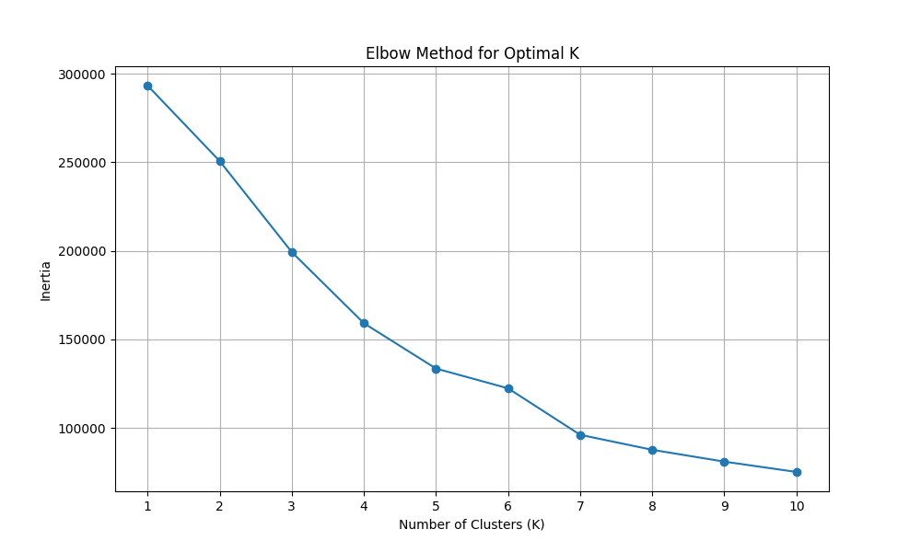
Figure 1. Elbow Method showing optimal cluster number (k = 3)

These methods were chosen to balance predictive power with interpretability, allowing accurate price forecasting and actionable customer segmentation. The following section presents key results supported by visualisations.

- RESULTS
4.1. Regression Results
The following models were applied to predict nightly listing prices: Ridge Regression as a baseline and Random Forest Regressor to capture non-linear relationships. Performance was evaluated using Mean Absolute Error (MAE), Root Mean Squared Error (RMSE), and R². Random Forest significantly outperformed Ridge Regression, achieving an MAE of 48.29 and an R² of 0.47, compared with 54.32 and 0.37 respectively.
Figure 2 illustrates predicted versus actual listing prices, showing Random Forest estimates more closely aligned with observed values. Both models struggled with luxury outliers, a limitation noted in prior Airbnb studies where extreme values distort predictive stability (Zhang et al., 2017).

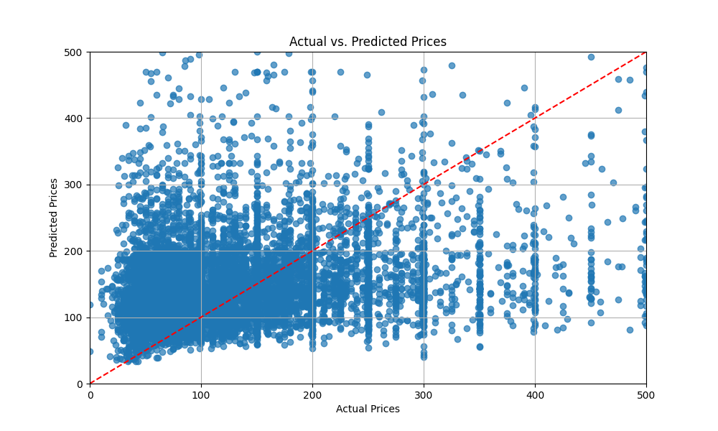
Figure 2: Predicted vs Actual Listing Prices Using Random Forest Regression

Feature importance analysis (Figure 3) identified room type and neighbourhood group as the strongest price determinants, while review-based variables played a minor role. This confirms that property characteristics and location dominate Airbnb pricing (Li & Xie, 2020). Consistent with broader literature, Random Forest offers higher accuracy in complex datasets (Zhou et al., 2023), while interpretable models such as Ridge Regression or Generalised Additive Models (GAM) remain valuable for transparency and stakeholder trust (James et al., 2021; Kruschel, 2025).
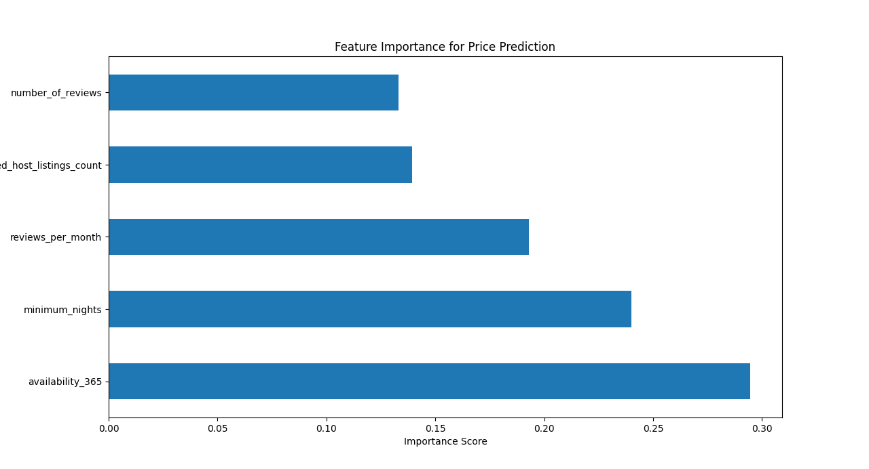
Figure 3: Feature Importance Ranking from Random Forest Regression

4.2. Clustering Results
K-Means clustering was applied to numerical features (price, minimum nights, number of reviews, availability) to identify natural customer and host segments. The Elbow Method (Figure 1) determined the optimal cluster number, validated by silhouette scores, indicating four meaningful groupings.
The analysis revealed distinct behavioural patterns. Figure 4 highlights how budget, short-stay listings with high engagement formed one cluster, while long-term rentals with high minimum nights but lower activity formed another. A further cluster represented premium, niche properties appealing to more specific traveller needs.
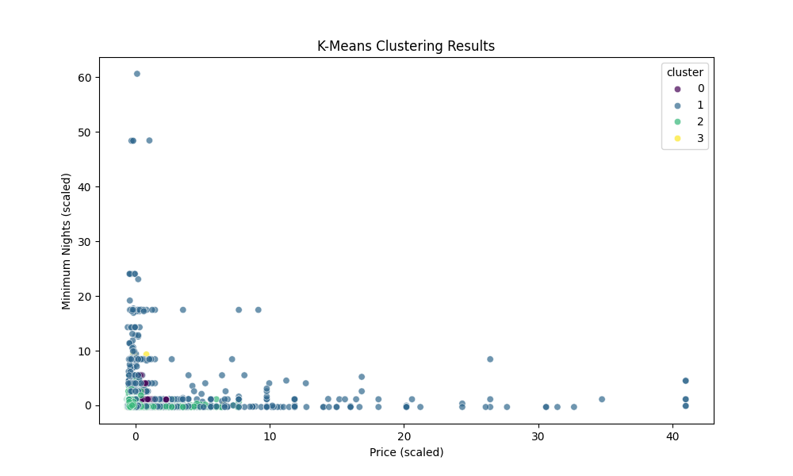
Figure 4: Clusters of Airbnb Listings by Price and Minimum Nights

Differences in customer demand are clear. Figure 5 shows that high-demand popular listings with many reviews formed a distinct cluster from underperforming but highly available units, and newer properties with limited engagement. These segments suggest recognisable customer personas: budget travellers, long-term guests, and high-frequency reviewers.
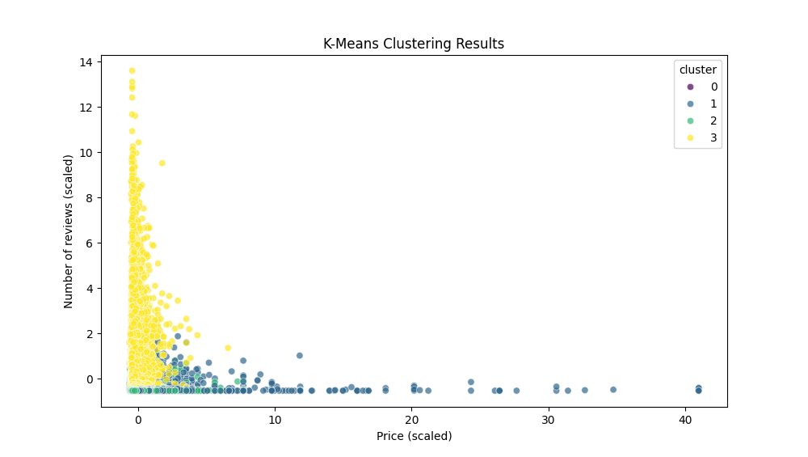
Figure 5: Clusters of Airbnb Listings by Price and Number of Reviews

These findings align with best practices in tourism segmentation, emphasising actionable and interpretable clusters for strategy (Dolnicar & Grün, 2013). Ding et al. (2023) further demonstrated that guest preferences vary systematically across price ranges, reinforcing the business value of clustering for Airbnb’s pricing and marketing strategies.

- DISCUSSION
This analysis highlights the complementary strengths of regression and clustering. Random Forest achieved stronger predictive performance than Ridge Regression, consistent with findings that tree-based models often excel on complex datasets (Chatzimparmpas et al., 2020). Ridge Regression, however, retains value for its interpretability, offering clearer explanations of price drivers to hosts and regulators. This trade-off mirrors industry practice, where linear models remain widely used despite lower accuracy because they enhance trust and transparency (StackExchange, 2024).
For Airbnb, the strategic issue is balancing predictive accuracy with interpretability. Random Forest can optimise internal revenue forecasting, while interpretable models such as Ridge or GAM are better suited for explaining pricing decisions externally. This dual approach provides both operational efficiency and stakeholder confidence.
Clustering added a behavioural perspective by identifying customer personas. These segments, budget travellers, long-term guests, and high-demand reviewers align with best practices that emphasise actionable, interpretable clusters (D’Urso et al., 2021). They also support evidence that guest preferences vary systematically across price ranges (Ding et al., 2023), enabling Airbnb to personalise marketing, adjust availability strategies, and guide host recommendations.
Limitations include reliance on NYC 2019 data, which excludes post-pandemic changes, and K-Means’ sensitivity to outliers and spherical assumptions. Future research could adopt hybrid or explainable boosting models and integrate text and image features, enhancing both predictive accuracy and transparency to strengthen Airbnb’s competitiveness.

- CONCLUSION AND RECOMMENDATIONS
This project addressed two strategic questions for Airbnb: how accurately listing prices in NYC can be predicted, and whether customer segmentation can inform pricing strategies. The analysis demonstrated that Random Forest regression delivered stronger predictive accuracy than Ridge Regression, with room type and neighbourhood emerging as key price drivers. Clustering revealed distinct customer personas: budget travellers, long-term guests, and high-demand reviewers that can be leveraged for more targeted strategies.
Recommendations for Airbnb:
- Optimise pricing: Use Random Forest for internal revenue forecasting while offering interpretable models (e.g., Ridge or GAMs) to maintain host and regulator trust.
- Tailor strategies: Apply clustering insights to segment customers and guide targeted marketing and host recommendations.
- Future innovation: Explore hybrid models and integrate text/image analysis to capture experiential quality, balancing accuracy with transparency.

- REFERENCES
Breiman, L. (2001) ‘Random forests’, Machine Learning, 45(1), pp. 5–32. Available at: https://doi.org/10.1023/A:1010933404324
Chatzimparmpas, A., Martins, R.M., Kucher, K. and Kerren, A. (2020) ‘A survey of surveys on the use of visualization for interpreting machine learning models’, Information Visualization, 19(3), pp. 207–233. Available at: https://doi:10.1177/1473871620904671
Chua, E.L., Chiu, J.L. and Bool, N.C. (2019) ‘Sharing economy: An analysis of Airbnb business model and the factors that influence consumer adoption’, Review of Integrative Business and Economics Research, 8(2), pp. 19. Available at: https://buscompress.com/uploads/3/4/9/8/34980536/riber_8-s2_03_h18-019_19-37.pdf (Accessed: 28 August 2025).
D’Urso, P., De Giovanni, L., Massari, R. and Vitale, V. (2021) ‘A clustering approach with mixed information in tourism market segmentation’, Social Indicators Research, 154(1), pp. 189–215. Available at: https://doi:10.1007/s11205-020-02537-y
Ding, Y., Lu, Z. and Xie, K.L. (2023) ‘Exploring guest preferences across price ranges: Evidence from Airbnb reviews using topic modeling’, Sustainability, 15(3), pp. 998. Available at: https://doi:10.3390/su15030998
Dolnicar, S. and Grün, B. (2013) ‘Market segmentation analysis: Understanding it, doing it, and making it useful’, Journal of Strategic Marketing, 21(2), pp. 175–188. Available at: https://doi:10.1080/0965254X.2012.742128
Dutt, S., Chandramouli, S. and Kumar Das, A. (2018) Machine Learning. 1st ed. India: Pearson. Available at: https://learning.oreilly.com/library/view/machine-learning-1st/9789353067373/ (Accessed 1 September 2025).
Guttentag, D., Smith, S., Potwarka, L. and Havitz, M. (2018) ‘Why tourists choose Airbnb: A motivation-based segmentation study’, Journal of Travel Research, 57(3), pp. 342-359. Available at: https://doi.org/10.1177/00472875176969
James, G., Witten, D., Hastie, T. and Tibshirani, R. (2021) An Introduction to Statistical Learning with Applications in Python. 2nd ed. New York: Springer. Available at: https://doi.org/10.1007/978-1-0716-1418-1
Kruschel, S., Hambauer, N., Weinzierl, S., Zilker, S., Kraus, M. and Zschech, P. (2025) ‘Challenging the performance-interpretability trade-off: an evaluation of interpretable machine learning models’, Business & Information Systems Engineering, pp. 1-25. Available at: https://doi.org/10.1007/s12599-024-00922-2
Kwok, L. and Xie, K.L. (2019) ‘Pricing strategies on Airbnb: Are multi-unit hosts revenue pros?’, International Journal of Hospitality Management, 82, pp. 252-259. Available at: https://doi.org/10.1016/j.ijhm.2018.09.013
Li, Y. and Xie, S. (2020) ‘Rent price dynamics of Airbnb in New York’, 2020 5th International Conference on Economics Development, Business & Management (EDBM 2020) Rent, pp. 472-75. Available at: https://doi:10.25236/edbm.2020.084
Oskam, J. and Boswijk, A. (2016) ‘Airbnb: the future of networked hospitality businesses’, Journal of Tourism Futures, 2(1), pp. 22-42. Available at: https://doi:10.1108/JTF-11-2015-0048
StackExchange. (2024) Why do we still use linear models when tree-based models often work better? Cross Validated. Available at: https://stats.stackexchange.com/questions/635642/why-do-we-use-linear-models-when-tree-based-models-often-work-better-than-linear (Accessed: 22 August 2025).
Zhou, Z., Qiu, C. and Zhang, Y. (2023) ‘A comparative analysis of linear regression, neural networks and random forest regression for predicting air ozone employing soft sensor models’, Scientific Reports, 13. Available at: https://doi.org/10.1038/s41598-023-49899-0
Zhang, Z., Chen, R.J., Han, L.D. and Yang, L. (2017) ‘Key factors affecting the price of Airbnb listings: A geographically weighted approach’, Sustainability, 9(9), p. 1635. Available at: https://doi.org/10.3390/su9091635

- Appendices

Appendix A: Cleaning scripts for original Airbnb dataset
# Python Requirements
import os

# External Requirements
import pandas as pd
import numpy as np
from scipy import stats
import matplotlib.pyplot as plt
import seaborn as sns

# Get file
fileDir = os.path.dirname(__file__)
filePath = os.path.join(fileDir, 'AB_NYC_2019.csv')

# Load into data-frame
df = pd.read_csv(filePath)

print()
print(df)

missing_info = df.isnull().sum().reset_index() # Boolean dataframe, sum columns, convert back to dataframe
missing_info.columns = ['Column', 'Total Missing Values'] # Name Columns
missing_info['% Missing'] = (missing_info['Total Missing Values'] / len(df)) * 100 # Create % column

print()
print(missing_info)

# Convert Datatypes
df['last_review'] = pd.to_datetime(df['last_review'])
df['neighbourhood_group'] = df['neighbourhood_group'].astype('category')
df['neighbourhood'] = df['neighbourhood'].astype('category')
df['room_type'].astype('category')

print()
print(df['neighbourhood_group'].values)
print(df.dtypes)

# Replace missing values & Drop
df.fillna({ 'name': 'N/A' }, inplace=True)
df.drop(columns=['id', 'host_name'], inplace=True)
df.fillna({ 'reviews_per_month': 0 }, inplace=True)
print()
print(df.head())
print(df.isnull().sum())

earliest_date = df['last_review'].min()
print()
print(earliest_date)

# Replace missing dates with 2000-01-01
df['last_review'] = df['last_review'].fillna(pd.Timestamp('2000-01-01'))
print()
print(df.isnull().sum())
print(df)

print()
print(df.describe())

for outlier in ['price', 'minimum_nights', 'number_of_reviews', 'reviews_per_month', 'calculated_host_listings_count']:
plt.figure(figsize=(5,5))
sns.boxplot(x=df[outlier])
plt.show()

df_numerics = df.select_dtypes(include=[np.number])

# Id outliers
print()
for col in df_numerics:
z_score = np.abs(stats.zscore(df[col]))
outliers_num = len(np.where(z_score > 3)[0])
if (outliers_num):
print('{}: {}'.format(col, outliers_num))

# Use z_scores to remove outliers
z_scores = np.abs(stats.zscore(df_numerics))

# Remove
df_no_outliers = df[(z_scores < 3).all(axis=1)]
print()
print(df_no_outliers.shape)

print()
final_df = df_no_outliers[df_no_outliers['price'] > 0]
print(final_df)
df.to_csv('cleandata.csv', index=False)

Appendix B1: Scripts for EDA of the cleaned dataset
# Format Datatypes
if 'last_review' in cdf.columns:
cdf['last_review'] = pd.to_datetime(cdf['last_review'], errors='coerce')
cdf['last_review'] = cdf['last_review'].fillna(pd.Timestamp('2000-01-01'))
if 'neighbourhood_group' in cdf.columns:
cdf['neighbourhood_group'] = cdf['neighbourhood_group'].astype('category')
if 'neighbourhood' in cdf.columns:
cdf['neighbourhood'] = cdf['neighbourhood'].astype('category')
if 'room_type' in cdf.columns:
cdf['room_type'] = cdf['room_type'].astype('category')

[print(datapoint) for datapoint in [cdf.info(), cdf.describe(), cdf.tail(), cdf.shape]]
print()

# Examine Numerical Features
numeric_features = cdf.select_dtypes(include=[np.number])
print(numeric_features.columns)

categorical_features = cdf.select_dtypes(include=['category'])
print(categorical_features.columns)
print()

# no need to visualise missing data, this was all removed during cleaning
# no need for msno heatmap/barchart as no missing values.
# no need for msno dendrogram as no missing values.

price_skew = skew(cdf['price'])
print(price_skew)
price_kurtosis = kurtosis(cdf['price'])
print(price_kurtosis)

Appendix B2: Scripts for EDA of the cleaned dataset (price prediction exploration)
# price distribution
plt.figure(figsize=(8,5))
sns.histplot(cdf['price'], bins=50, kde=True)
plt.title("Price Distribution")
plt.xlabel("Price")
plt.ylabel("Count")
plt.show()

# Statistical test for price distribution
normality_flag = None
n = len(cdf['price'])
if n <= 5000:
shapiro_stat, shapiro_p = stats.shapiro(df['price'])
print(f"Shapiro–Wilk test: W={shapiro_stat:.4f}, p={shapiro_p:.4f}")
normality_flag = shapiro_p >= 0.05
else:
ad_stat, crit_vals, sig_levels = stats.anderson(cdf['price'], dist='norm')
print(f"Anderson–Darling test: A²={ad_stat:.4f}")
for cv, sl in zip(crit_vals, sig_levels):
print(f" {sl}%: {cv:.4f}")
normality_flag = all(ad_stat < cv for cv in crit_vals)

print('Normal' if normality_flag else 'Not Normal')
# Q-Q plot just to visually check normality
stats.probplot(cdf['price'], dist="norm", plot=plt)
plt.title("Q–Q Plot for Price")
plt.show()

# not normally distributed. AD TEST value > sig level value at 5%

# price by room type
plt.figure(figsize=(8,5))
sns.boxplot(data=cdf, x='room_type', y='price')
plt.ylim(0, cdf['price'].quantile(0.95))
plt.title("Price by Room Type")
plt.show()

# ANOVA or Kruskal–Wallis as stat test
groups = [cdf.loc[cdf['room_type'] == rt, 'price'] for rt in cdf['room_type'].unique()]
if normality_flag:
anova_stat, anova_p = stats.f_oneway(*groups)
print(f"ANOVA across room types: F={anova_stat:.4f}, p={anova_p:.4f}")
if anova_p < 0.05:
print("Tukey's HSD for Room Types:")
tukey_result = pairwise_tukeyhsd(endog=cdf['price'], groups=cdf['room_type'], alpha=0.05)
print(tukey_result)
else:
kw_stat, kw_p = stats.kruskal(*groups)
print(f"Kruskal–Wallis across room types: H={kw_stat:.4f}, p={kw_p:.4f}")
# if ANOVA is significant we will do Tukey HSD to see which groups differ significantly

# average price by neighbourhood group
if 'room_type' in cdf.columns:
plt.figure(figsize=(8,5))
sns.barplot(data=cdf, x='neighbourhood_group', y='price', errorbar=None)
plt.title("Average Price by Neighbourhood")
plt.show()

# ANOVA for significance

borough_groups = [cdf.loc[cdf['neighbourhood_group'] == b, 'price']
for b in cdf['neighbourhood_group'].unique()]
anova_stat, anova_p = stats.f_oneway(*borough_groups)
print(f"ANOVA across boroughs: F={anova_stat:.4f}, p={anova_p:.4f}")
if anova_p < 0.05:
print("\nTukey's HSD for Boroughs:")
tukey_result = pairwise_tukeyhsd(endog=cdf['price'], groups=cdf['neighbourhood_group'], alpha=0.05)
print(tukey_result)

#correlation heatmap
plt.figure(figsize=(8,5))
numeric_cdf = cdf.select_dtypes(include=[np.number])
sns.heatmap(numeric_cdf.corr(), annot=True, cmap='coolwarm')
plt.title("Correlation Heatmap")
plt.show()

Appendix B3: Scripts for EDA of the cleaned dataset (customer segmentation exploration)
# choosing features for clustering
features = ['minimum_nights', 'number_of_reviews', 'reviews_per_month', 'availability_365']
seg_cdf = cdf[[f for f in features if f in cdf.columns]].copy()

#fill missing values
seg_cdf = seg_cdf.fillna(0)

#scale features
scaler = StandardScaler()
scaled_features = scaler.fit_transform(seg_cdf)

#PCA for visualisation
pca = PCA(n_components=2)
pca_features = pca.fit_transform(scaled_features)
pca_cdf = pd.DataFrame(pca_features, columns=['PC1', 'PC2'])

#plot PCA scatter (pre-clustering)
plt.figure(figsize=(8, 6))
sns.scatterplot(data=pca_cdf, x='PC1', y='PC2', alpha=0.5)
plt.title("PCA Projection of Listings (for Segmentation)")
plt.show()

print(f"PCA explained variance ratio: {pca.explained_variance_ratio_}")

Appendix C: Scripts for regression model
import argparse, os, joblib, json
import pandas as pd
from sklearn.model_selection import train_test_split
from sklearn.compose import ColumnTransformer
from sklearn.preprocessing import OneHotEncoder, StandardScaler
from sklearn.pipeline import Pipeline
from sklearn.metrics import mean_absolute_error, mean_squared_error, r2_score
from sklearn.linear_model import Ridge
from sklearn.ensemble import RandomForestRegressor

NUMERIC = [
'latitude', 'longitude', 'minimum_nights', 'number_of_reviews',
'reviews_per_month', 'calculated_host_listings_count', 'availability_365'
]
CATEGORICAL = ['neighbourhood_group', 'neighbourhood', 'room_type']

def minimal_clean(df, target):
df = df.copy()
df = df[(df[target] > 0) & (df[target] <= 1000)]
if 'reviews_per_month' in df.columns:
df['reviews_per_month'] = df['reviews_per_month'].fillna(0.0)
return df

def build_preprocessor():
num = Pipeline([('scaler', StandardScaler())])
cat = OneHotEncoder(handle_unknown='ignore', sparse=False, min_frequency=50)
return ColumnTransformer([('num', num, NUMERIC), ('cat', cat, CATEGORICAL)])

def evaluate(y_true, y_pred):
return {
'MAE': float(mean_absolute_error(y_true, y_pred)),
'RMSE': float(mean_squared_error(y_true, y_pred, squared=False)),
'R2': float(r2_score(y_true, y_pred))
}

def main(args):
df = pd.read_csv(args.data)
if args.auto_clean:
df = minimal_clean(df, args.target)
used = NUMERIC + CATEGORICAL + [args.target]
df = df[used].dropna()
X = df.drop(columns=[args.target])
y = df[args.target]

X_train, X_test, y_train, y_test = train_test_split(
X, y, test_size=args.test_size, random_state=args.random_state, stratify=df['room_type']
)

pre = build_preprocessor()

ridge = Pipeline([('preprocess', pre), ('model', Ridge(alpha=1.0, random_state=42))])
rf = Pipeline([('preprocess', pre), ('model', RandomForestRegressor(
n_estimators=args.n_estimators,
min_samples_split=4,
min_samples_leaf=2,
n_jobs=-1,
random_state=args.random_state
))])

ridge.fit(X_train, y_train)
rf.fit(X_train, y_train)

out = {}
for name, model in [('Ridge', ridge), ('RandomForest', rf)]:
y_pred = model.predict(X_test)
out[name] = evaluate(y_test, y_pred)

os.makedirs(args.report_dir, exist_ok=True)
pd.DataFrame([{'model':k, **v} for k,v in out.items()]).to_csv(
os.path.join(args.report_dir, 'regression_metrics.csv'), index=False
)

joblib.dump(ridge, os.path.join(args.model_dir, 'ridge_pipeline.joblib'))
joblib.dump(rf, os.path.join(args.model_dir, 'rf_pipeline.joblib'))

print(json.dumps(out, indent=2))

if __name__ == '__main__':
p = argparse.ArgumentParser()
p.add_argument('--data', type=str, required=True)
p.add_argument('--target', type=str, default='price')
p.add_argument('--auto-clean', action='store_true')
p.add_argument('--test-size', type=float, default=0.2)
p.add_argument('--random-state', type=int, default=42)
p.add_argument('--n-estimators', type=int, default=150)
p.add_argument('--report-dir', type=str, default='reports')
p.add_argument('--model-dir', type=str, default='.')
args = p.parse_args()
main(args)

Appendix D: Scripts for clustering method
# import libraries %%
import pandas as pd
import seaborn as sns
import matplotlib.pyplot as plt

# %%
fileDir = os.path.dirname(__file__)
filePath = os.path.join(fileDir, 'cleandata.csv')
df=pd.read_csv(filePath)

# %%
print(df.columns)

#Created a correlation heatmap to understand relationships %%
plt.figure(figsize=(10, 6))
sns.heatmap(df[['price', 'minimum_nights', 'number_of_reviews', 'reviews_per_month', 'availability_365', 'calculated_host_listings_count']].corr(), annot=True, cmap='coolwarm')
plt.title('Correlation Heatmap')
plt.tight_layout()
plt.show()

#Distribution of Room Types by Neighbourhood Group %%
plt.figure(figsize=(10, 6))
sns.countplot(data=df, x='neighbourhood_group', hue='room_type')
plt.title('Distribution of Room Types by Neighbourhood Group')
plt.xlabel('Neighbourhood Group')
plt.ylabel('Count')
plt.xticks(rotation=45)
plt.legend(title='Room Type')

#Price distribution graph %%
plt.figure(figsize=(10, 6))
sns.histplot(df['price'], bins=50, kde=True)
plt.title('Price Distribution')
plt.xlabel('Price')
plt.ylabel('Frequency')
plt.xlim(0, 500) # Limit x-axis to the maximum price # Limit y-axis to a reasonable value for
plt.show()

#initialized relevant variables %%
features = [['price', 'minimum_nights', 'number_of_reviews', 'reviews_per_month', 'availability_365', 'calculated_host_listings_count']]

# Numerical features normalization%%
from sklearn.preprocessing import StandardScaler

scaler = StandardScaler()
X_scaled = scaler.fit_transform(df[features[0]])

# Elbow method %%
from sklearn.cluster import KMeans

inertia = []
K= range(1, 11)

for k in K:
kmeans = KMeans(n_clusters=k, random_state=42)
kmeans.fit(X_scaled)
inertia.append(kmeans.inertia_)

plt.figure(figsize=(10, 6))
plt.plot(K, inertia, marker='o')
plt.title('Elbow Method for Optimal K')
plt.xlabel('Number of Clusters (K)')
plt.ylabel('Inertia')
plt.xticks(K)
plt.grid(True)
plt.show()

# Silhouette score %%
from sklearn.metrics import silhouette_score

for k in range(2, 11):
kmeans = KMeans(n_clusters=k, random_state=42)
preds = kmeans.fit_predict(X_scaled)
score = silhouette_score(X_scaled, preds)
print(f'Silhouette Score for k={k}: {score:.4f}')

# Choosing best k %%
best_k = 4
kmeans=KMeans(n_clusters=best_k,random_state=42)
df['cluster']=kmeans.fit_predict(X_scaled)
# Replace with the optimal k found from the elbow method or silhouette score

# Plotting cluster trhough relevant variables %%
plt.figure(figsize=(10, 6))
sns.scatterplot(x=X_scaled[:, 0], y=X_scaled[:, 1], hue=df['cluster'], palette='viridis', alpha=0.7)
plt.title('K-Means Clustering Results')
plt.xlabel('Price (scaled)')
plt.ylabel('Minimum Nights (scaled)')

# %%
plt.figure(figsize=(10, 6))
sns.scatterplot(x=X_scaled[:, 0], y=X_scaled[:, 2], hue=df['cluster'], palette='viridis', alpha=0.7)
plt.title('K-Means Clustering Results')
plt.xlabel('Price (scaled)')
plt.ylabel('Number of reviews (scaled)')

# %%
plt.figure(figsize=(10, 6))
sns.scatterplot(x=X_scaled[:, 0], y=X_scaled[:, 3], hue=df['cluster'], palette='viridis', alpha=0.7)
plt.title('K-Means Clustering Results')
plt.xlabel('Price (scaled)')
plt.ylabel('Reviews per month (scaled)')

# %%
plt.figure(figsize=(10, 6))
sns.scatterplot(x=X_scaled[:, 0], y=X_scaled[:, 4], hue=df['cluster'], palette='viridis', alpha=0.7)
plt.title('K-Means Clustering Results')
plt.xlabel('Price (scaled)')
plt.ylabel('Reviews per month (scaled)')

Appendix E: Visualisation scripts

import os

# import libraries %%
import pandas as pd
import seaborn as sns
import matplotlib.pyplot as plt

# %%
fileDir = os.path.dirname(__file__)
filePath = os.path.join(fileDir, 'cleandata.csv')
df=pd.read_csv(filePath)

# %%
print(df.columns)

#Created a correlation heatmap to understand relationships %%
plt.figure(figsize=(10, 6))
sns.heatmap(df[['price', 'minimum_nights', 'number_of_reviews', 'reviews_per_month', 'availability_365', 'calculated_host_listings_count']].corr(), annot=True, cmap='coolwarm')
plt.title('Correlation Heatmap')
plt.tight_layout()
plt.show()

#Distribution of Room Types by Neighbourhood Group %%
plt.figure(figsize=(10, 6))
sns.countplot(data=df, x='neighbourhood_group', hue='room_type')
plt.title('Distribution of Room Types by Neighbourhood Group')
plt.xlabel('Neighbourhood Group')
plt.ylabel('Count')
plt.xticks(rotation=45)
plt.legend(title='Room Type')

#Price distribution graph %%
plt.figure(figsize=(10, 6))
sns.histplot(df['price'], bins=50, kde=True)
plt.title('Price Distribution')
plt.xlabel('Price')
plt.ylabel('Frequency')
plt.xlim(0, 500) # Limit x-axis to the maximum price # Limit y-axis to a reasonable value for
plt.show()

#initialized relevant variables %%
features = [['price', 'minimum_nights', 'number_of_reviews', 'reviews_per_month', 'availability_365', 'calculated_host_listings_count']]

# Numerical features normalization%%
from sklearn.preprocessing import StandardScaler

scaler = StandardScaler()
X_scaled = scaler.fit_transform(df[features[0]])

# Elbow method %%
from sklearn.cluster import KMeans

inertia = []
K= range(1, 11)

for k in K:
kmeans = KMeans(n_clusters=k, random_state=42)
kmeans.fit(X_scaled)
inertia.append(kmeans.inertia_)

plt.figure(figsize=(10, 6))
plt.plot(K, inertia, marker='o')
plt.title('Elbow Method for Optimal K')
plt.xlabel('Number of Clusters (K)')
plt.ylabel('Inertia')
plt.xticks(K)
plt.grid(True)
plt.show()

# Silhouette score %%
from sklearn.metrics import silhouette_score

for k in range(2, 11):
kmeans = KMeans(n_clusters=k, random_state=42)
preds = kmeans.fit_predict(X_scaled)
score = silhouette_score(X_scaled, preds)
print(f'Silhouette Score for k={k}: {score:.4f}')

# Choosing best k %%
best_k = 4
kmeans=KMeans(n_clusters=best_k,random_state=42)
df['cluster']=kmeans.fit_predict(X_scaled)
# Replace with the optimal k found from the elbow method or silhouette score

# Plotting cluster trhough relevant variables %%
plt.figure(figsize=(10, 6))
sns.scatterplot(x=X_scaled[:, 0], y=X_scaled[:, 1], hue=df['cluster'], palette='viridis', alpha=0.7)
plt.title('K-Means Clustering Results')
plt.xlabel('Price (scaled)')
plt.ylabel('Minimum Nights (scaled)')

# %%
plt.figure(figsize=(10, 6))
sns.scatterplot(x=X_scaled[:, 0], y=X_scaled[:, 2], hue=df['cluster'], palette='viridis', alpha=0.7)
plt.title('K-Means Clustering Results')
plt.xlabel('Price (scaled)')
plt.ylabel('Number of reviews (scaled)')

# %%
plt.figure(figsize=(10, 6))
sns.scatterplot(x=X_scaled[:, 0], y=X_scaled[:, 3], hue=df['cluster'], palette='viridis', alpha=0.7)
plt.title('K-Means Clustering Results')
plt.xlabel('Price (scaled)')
plt.ylabel('Reviews per month (scaled)')

# %%
plt.figure(figsize=(10, 6))
sns.scatterplot(x=X_scaled[:, 0], y=X_scaled[:, 4], hue=df['cluster'], palette='viridis', alpha=0.7)
plt.title('K-Means Clustering Results')
plt.xlabel('Price (scaled)')
plt.ylabel('Reviews per month (scaled)')

##Visualisations

#Box Plot of Price by Neighborhood Group
plt.figure(figsize=(12, 6))
sns.boxplot(data=df, x='neighbourhood_group', y='price')
plt.title('Box Plot of Price by Neighbourhood Group')
plt.xlabel('Neighbourhood Group')
plt.ylabel('Price')
plt.xticks(rotation=45)
plt.ylim(0, 500) # Limit y-axis to a reasonable value
plt.tight_layout()
plt.show()

#Cluster Characteristics Visualization
cluster_means = df.groupby('cluster')[['price', 'minimum_nights', 'number_of_reviews', 'reviews_per_month', 'availability_365']].mean().reset_index()
cluster_means.plot(x='cluster', kind='bar', figsize=(12, 6))
plt.title('Average Features per Cluster')
plt.xlabel('Cluster')
plt.ylabel('Average Values')
plt.xticks(rotation=0)
plt.tight_layout()
plt.show()

#Price vs. Number of Reviews Scatter Plot
plt.figure(figsize=(10, 6))
sns.scatterplot(data=df, x='number_of_reviews', y='price', hue='cluster', palette='viridis', alpha=0.7)
plt.title('Price vs. Number of Reviews')
plt.xlabel('Number of Reviews')
plt.ylabel('Price')
plt.ylim(0, 500) # Limit y-axis to a reasonable value
plt.legend(title='Cluster')
plt.show()

#Pair Plot (relationships between multiple features)
sns.pairplot(df[['price', 'minimum_nights', 'number_of_reviews', 'reviews_per_month', 'availability_365']], diag_kind='kde')
plt.suptitle('Pair Plot of Key Features', y=1.02)
plt.show()

#Feature Importance Plot (random forest model)
from sklearn.ensemble import RandomForestRegressor
from sklearn.model_selection import train_test_split

X = df[['minimum_nights', 'number_of_reviews', 'reviews_per_month', 'availability_365', 'calculated_host_listings_count']]
y = df['price']
X_train, X_test, y_train, y_test = train_test_split(X, y, test_size=0.2, random_state=42)

model = RandomForestRegressor(random_state=42)
model.fit(X_train, y_train)

feature_importances = pd.Series(model.feature_importances_, index=X.columns)
feature_importances.nlargest(5).plot(kind='barh')
plt.title('Feature Importance for Price Prediction')
plt.xlabel('Importance Score')
plt.show()

#Actual vs. Predicted Prices
y_pred = model.predict(X_test)
plt.figure(figsize=(10, 6))
plt.scatter(y_test, y_pred, alpha=0.7)
plt.plot([0, 500], [0, 500], '--r') # 45-degree line
plt.title('Actual vs. Predicted Prices')
plt.xlabel('Actual Prices')
plt.ylabel('Predicted Prices')
plt.xlim(0, 500)
plt.ylim(0, 500)
plt.grid()
plt.show()

#Cluster Profiles Visualization
cluster_profiles = df.groupby('cluster')[['price', 'minimum_nights', 'number_of_reviews', 'reviews_per_month', 'availability_365']].mean()
cluster_profiles.plot(kind='bar', figsize=(12, 6))
plt.title('Average Characteristics of Each Customer Segment')
plt.ylabel('Average Values')
plt.xticks(rotation=0)
plt.tight_layout()
plt.show()

#Heatmap of Clusters by Room Type and Neighborhood
cluster_room_neighborhood = df.pivot_table(values='price', index='room_type', columns=['neighbourhood_group', 'cluster'], aggfunc='mean')
plt.figure(figsize=(12, 8))
sns.heatmap(cluster_room_neighborhood, annot=True, cmap='YlGnBu')
plt.title('Heatmap of Average Price by Room Type, Neighbourhood Group, and Cluster')
plt.xlabel('Neighbourhood Group and Cluster')
plt.ylabel('Room Type')
plt.tight_layout()
plt.show()

Appendix F: Correlation heatmap to understand relationships
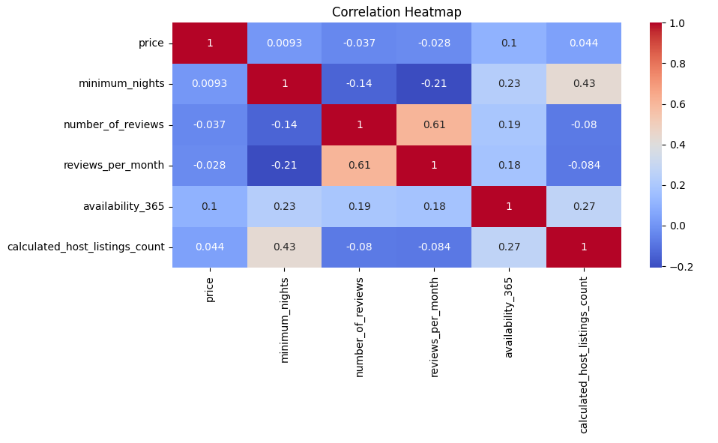Appendix G: Price distribution graph
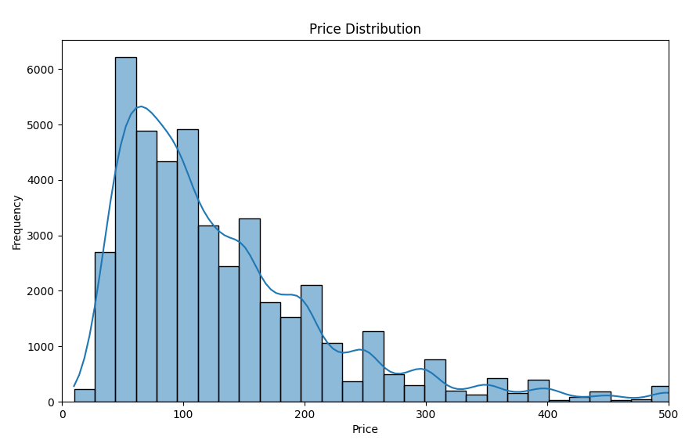

Appendix H: Distribution of Room Types by Neighbourhood Group
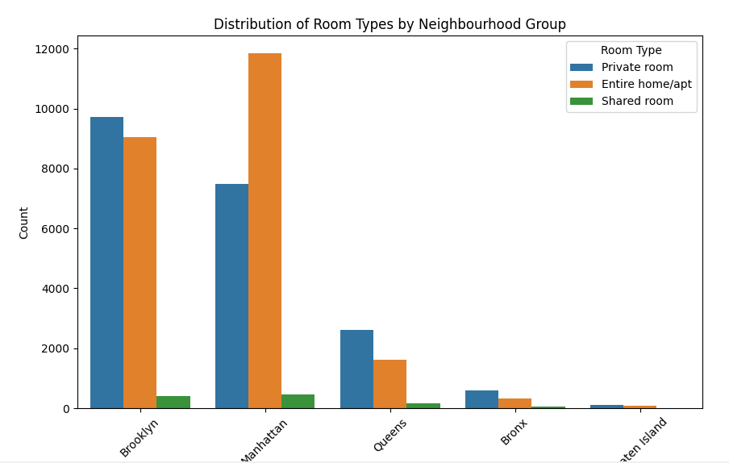

Appendix I1: K-Means Clustering Results for Price and Reviews per month
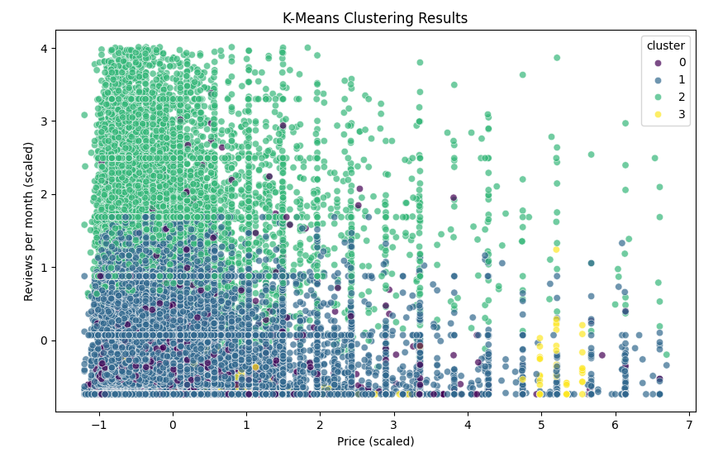

Appendix I2: K-Means Clustering Results for Price and Reviews per month (alternate scale)
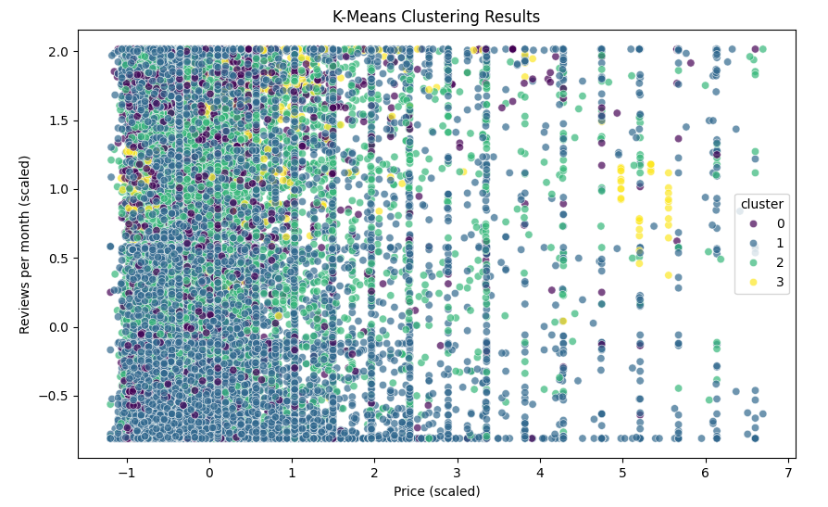

Appendix J: Box plot of Price By Neighbourhood Group
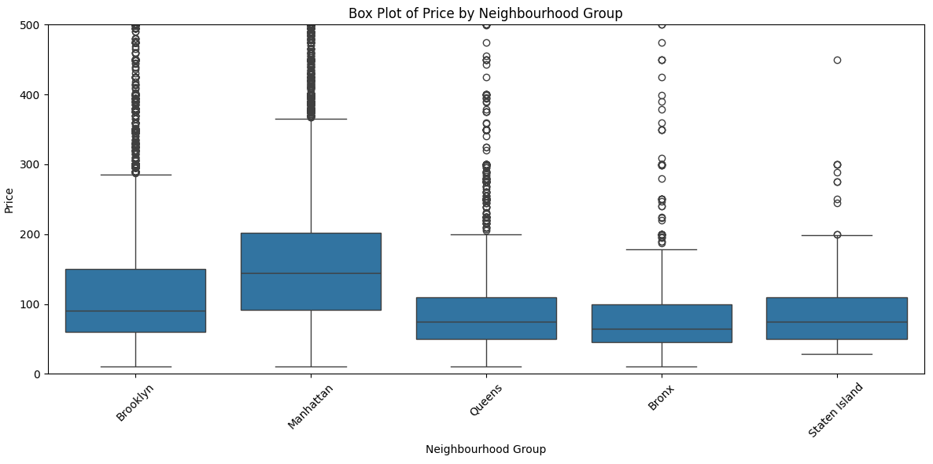

Appendix K: Cluster Characteristics Visualization
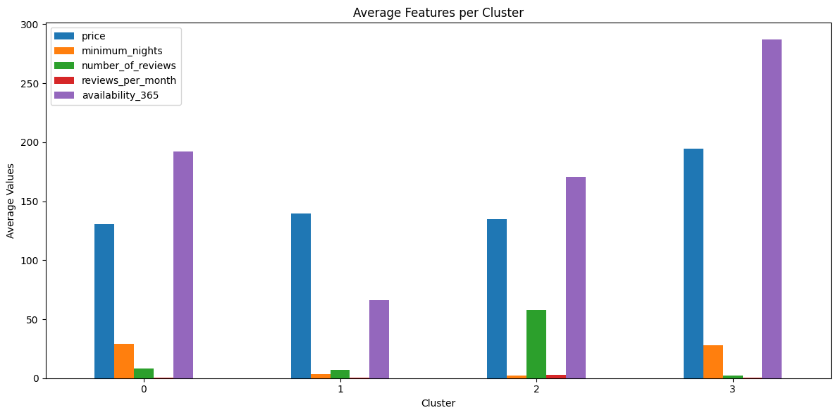

Appendix L: Price vs. Number of Reviews Clusters
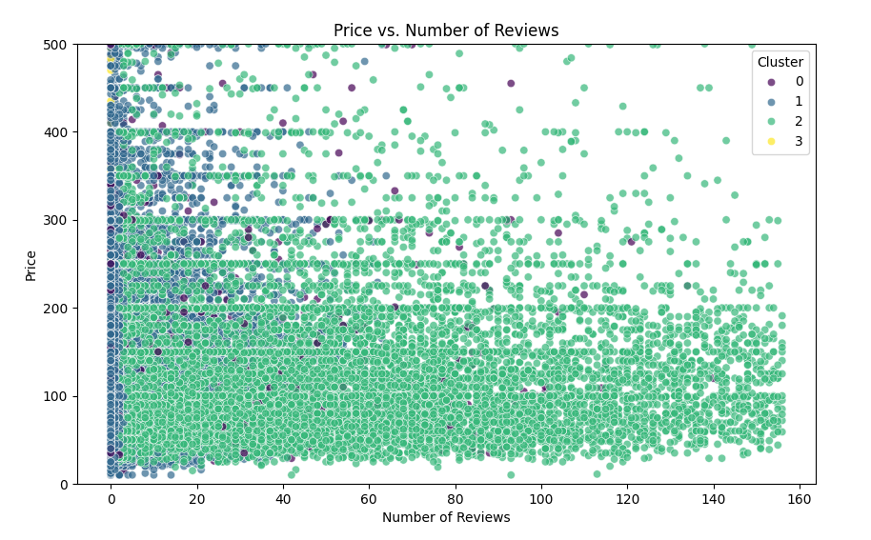

Appendix M: Pair Plot (relationships between multiple features)
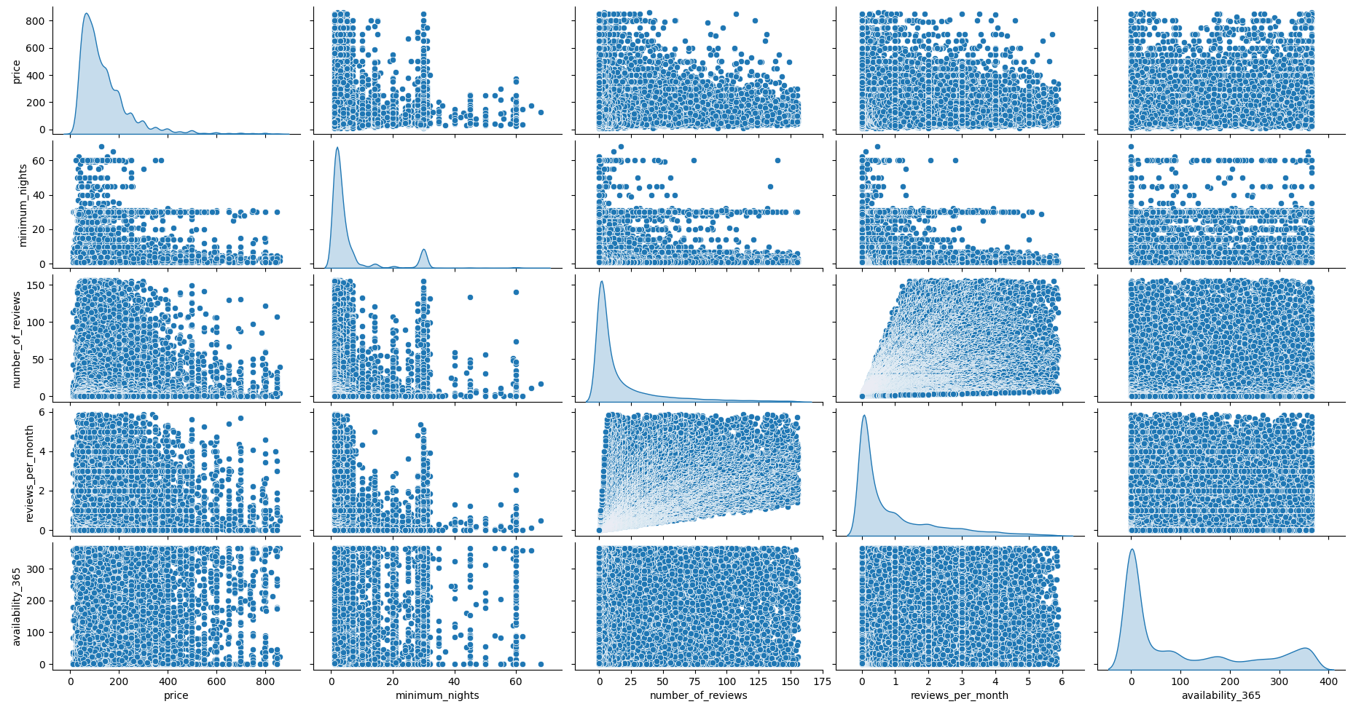

Appendix N: Bar Graph for the Average characteristics of each customer segment
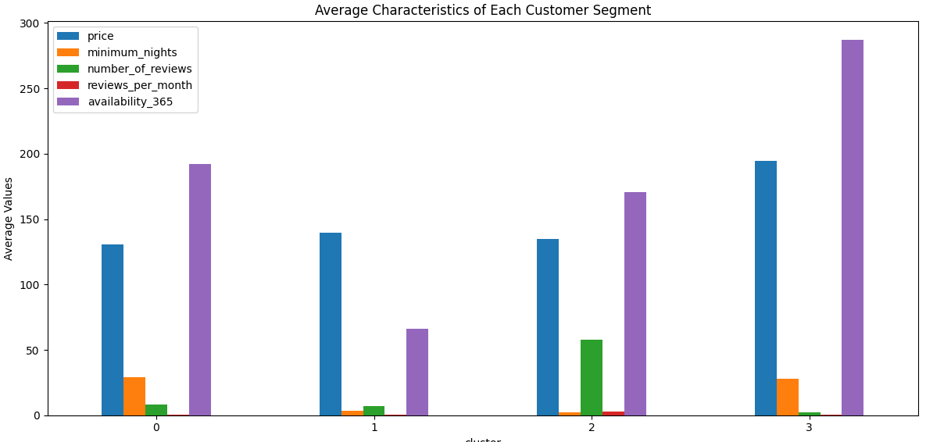

Appendix O: Heatmap of Clusters by Room Type and Neighbourhood
